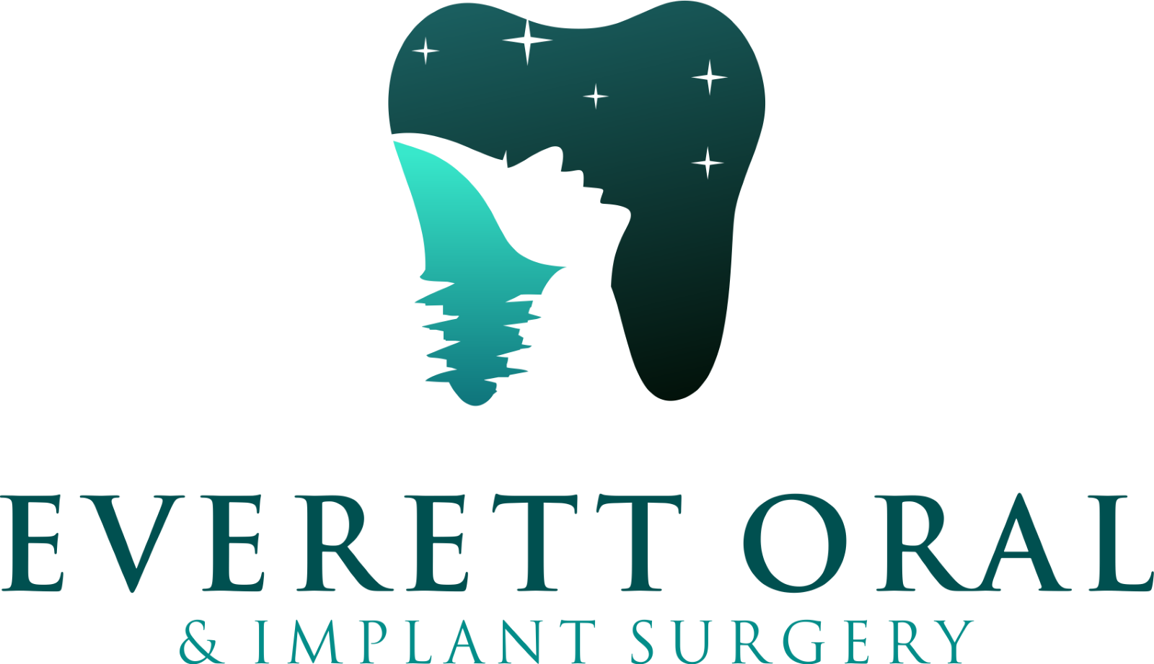

**POST-OPERATIVE INSTRUCTIONS FOR MAXILLARY SINUS EXPOSURE**

**Dr. Tae Youn, DDS MD**  
**Board Certified Oral Surgeon**  
**Office Phone: 425-318-4789**

You have an opening between your maxillary sinus and your oral cavity. Typically, these openings spontaneously heal. Sometimes, one or more corrective surgeries are necessary to correct this problem. If the following instructions are followed, then there will be a greater chance that your maxillary sinus exposure will heal without further intervention.

**SWELLING:**

Ice packs will help reduce the swelling but should never be placed directly on exposed skin. Rather, wrap an ice pack (or a package of frozen vegetables) in a damp towel and place gently on the sides of your face, 30 minutes on and 30 minutes off.

**NOSEBLEEDS**

Nosebleeds are normal and may occur for several days following surgery. Treat by leaning your head back; apply an ice pack and direct pressure. Drainage is normal from both the nose and mouth - wipe gently away.

**SNEEZING**

Try to avoid sneezing. If one comes on, sneeze through your mouth – Don’t pinch your nose!

**MEDICATION**

Start taking your prescribed pain medication before the local anesthesia wears off; take as directed by your dentist. Take as directed on the bottle.

**SMOKING**

Do not smoke at all after the surgery until the surgical site is fully healed (At least 2-6 weeks) to reduce your chances of having postoperative problems. Smoking can increase pain and lead to poor healing.

**BLOWING YOUR NOSE**

Avoid blowing your nose. When necessary, gently sniff and wipe the end of your nose. No negative or positive pressure in nose and mouth.